STOCK INVENTORY MANAGER
NET4207 – Lab Test Documentation
NAME:AKSHITHA KOLLI
ID:I26042893

1. Project Overview
Stock Inventory Manager is a flutter application that allows a small retail store to log stock items. I used Firebase Cloud Firestore as my database for the inventory. I have created a form to ensure valid stock items can be logged. It will display a screen to the user containing all inventory items within the database. The source code, documentation and evidential screenshots have been uploaded to GitHub. Inventory items have been stored in Firestore.
2. Firestore Data Model
Collection: stockItems | Document ID: Firestore auto-generated
FIELD | TYPE | REQUIREMENT
sku | String | STK-followed by three digits(eg:STK-101)
itemName | String | Trimmed;minimum 3 characters
category | String | Electronics,Stationery ,Hardware or Grocery
quantity | Integer | Whole number ; 0 or above
unitPrice | Number | RM amount greater than 0
reorderLevel | Integer | Whole number ;0 or above
createdAt | Integer | Server timestamp added on save

3. Form Validation and Firebase Operations
There are 6 required fields on this form: SKU, item name, category, quantity, unit price and reorder level. We can use a GlobalKey to make sure that our form is valid before submission. SKU must be in the format STK-3 digits. Item name must be at least 3 characters long after trimming. Category must be one of the categories we have allowed. Quantity and reorder level must be positive integers. Unit price must be more than RM 0. If there are invalid entries then they will be displayed in the appropriate field. We should not save invalid data to our firestore database. When we submit valid data it will be saved to the stockItems collection. We make sure that the data types are correct and that the createdAt field will be generated by the server. We should display some indication that our data is saving and give a success message once we get an acknowledgment from Firestore. Any errors should be displayed but the form should not be cleared. The inventory screen will retrieve our saved data from our firestore database.

4. Advanced Search and Inventory Display
The user will be able to search by part of itemName AND sku. They will also be able to filter by category with the options being All AND the 4 categories. They will be able to filter by low stock items meaning items with quantity <= reorderLevel. All the filtering should be done using AND. The items can be sorted by quantity in ascending or descending order. There should be a clear filters button which shows all items in inventory. The items should be clearly displayed with loading indicators, information saying no items found AND basic error handling.
5. Setup and Execution
1.Open your Flutter project.
2. Get dependencies:flutter pub get
3.Ensure your application is linked to THE Firebase project supplied by your lecturer with THE following details:
4.Firebase Project ID: [INSERT LECTURER PROVIDED FIREBASE PROJECT ID]
5.You can check which dependencies (including Firebase) are being used in THE application by looking at THE pubspec.yaml file.
6.Connect to an emulator/device or configured browser target and run:flutter run
6. Test Log
Complete the Actual Results for each test. The expected results are below based on the lab spec. You will need to ensure these tests have been performed within the app.
Test / Input | Expected Result | Actual Result | Evidence
Submit blank or malformed form data | Inline validation errors appear; no new Firestore document is created. | Error | Invalid form
Save STK-101, STK-102 and STK-103, then retrieve inventory | Three retrievable Firestore records appear with the correct values. | Stock Item saved successfully | Save and retrieve
Search “mouse” with Electronics and Low Stock enabled | Only STK-103 (Wireless Mouse) appears. | Items successfully retrievd | Combined search

7. Evidence Screenshots
Figure 1. Invalid form validation
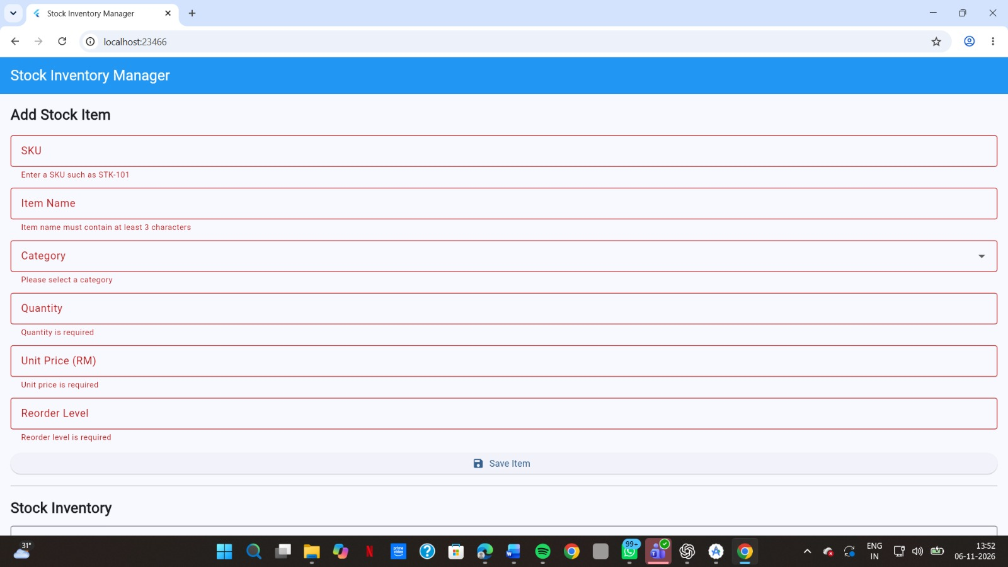
Figure 2. Firestore save and inventory retrieval
1.Added USB C CABLE
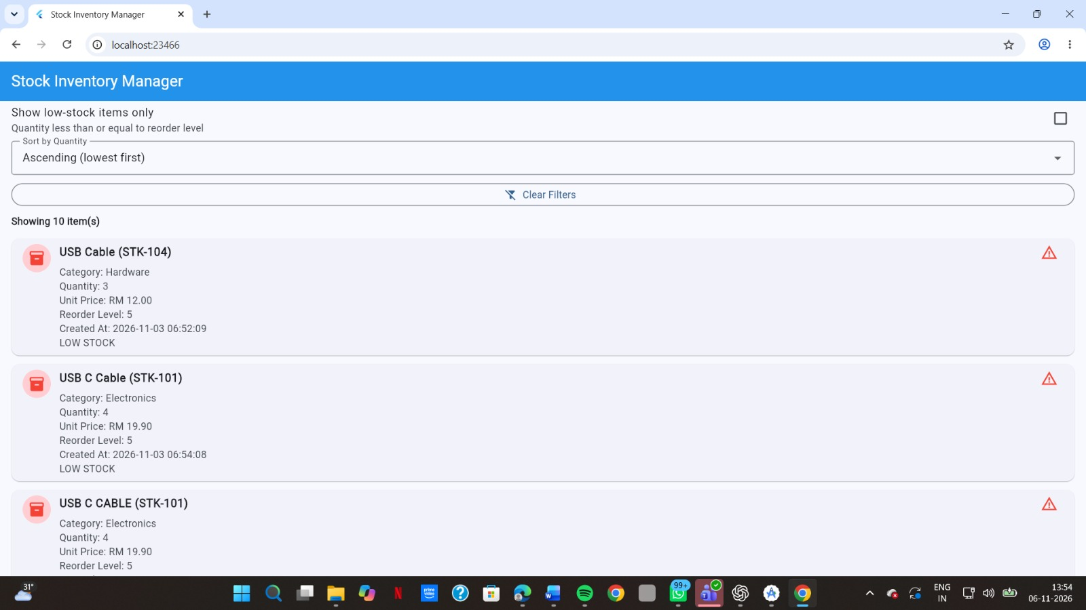

2.Notebook
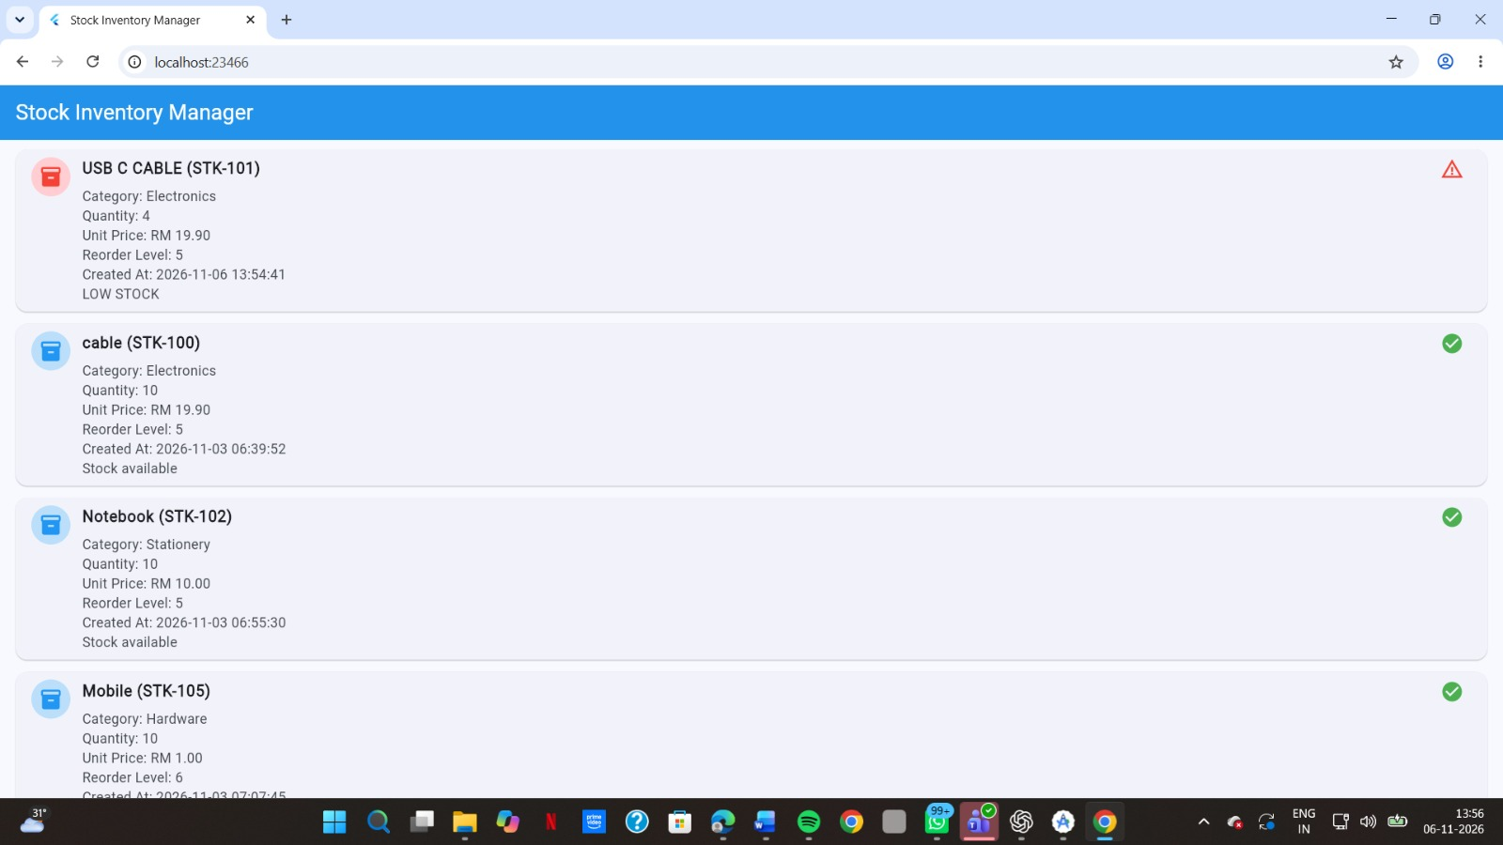
3.Added Wireless Mouse
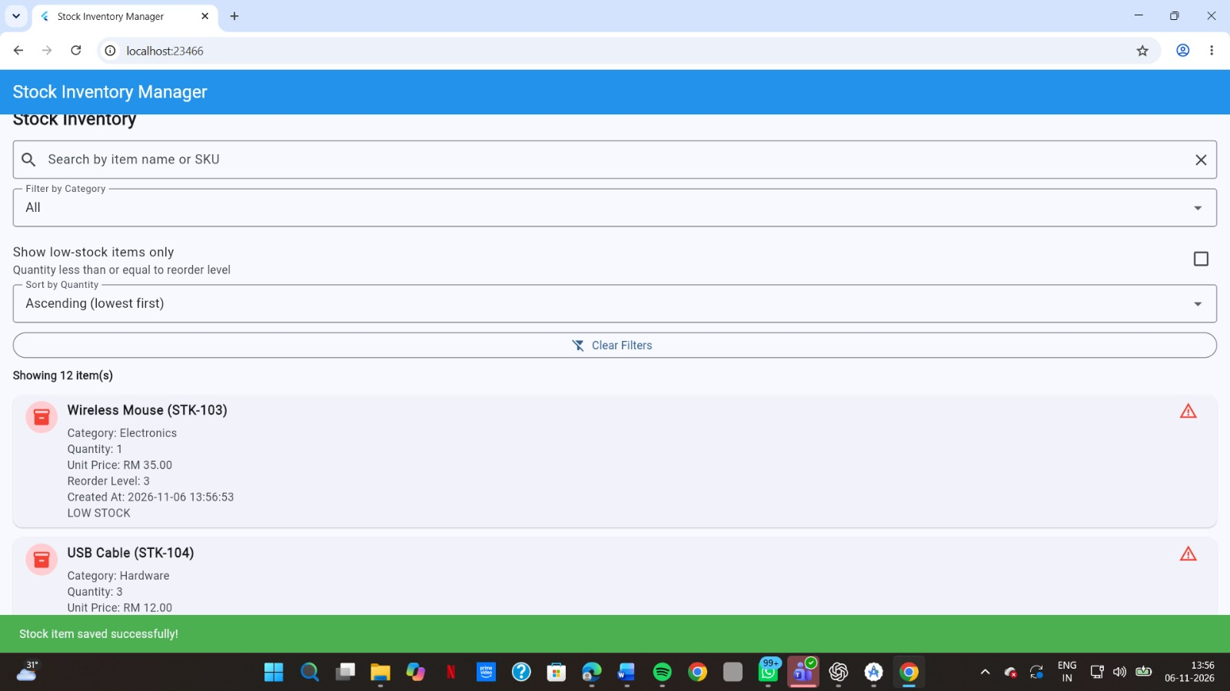
Figure 3. Combined search and low-stock filter


